Name: Tung Do Lab #6 Date: October 30, 2022

Objectives: The objective of this lab was to understand object-oriented programming, write classes and test them. In this lab, I need to create a class called complex to perform arithmetic with complex numbers, including adding 2 complex numbers, subtracting 2 complex numbers, and multiplying 2 complex numbers. Then print the result in a Message Dialog Box. Thus, in order to perform the lab, I need to know how to create a class, provide a constructor that enables an object of this class to be initialized when it is declared, and how to write a method and call it in the program.

**Program:**

**Results:**

* The console log executes and the message dialog shows the output

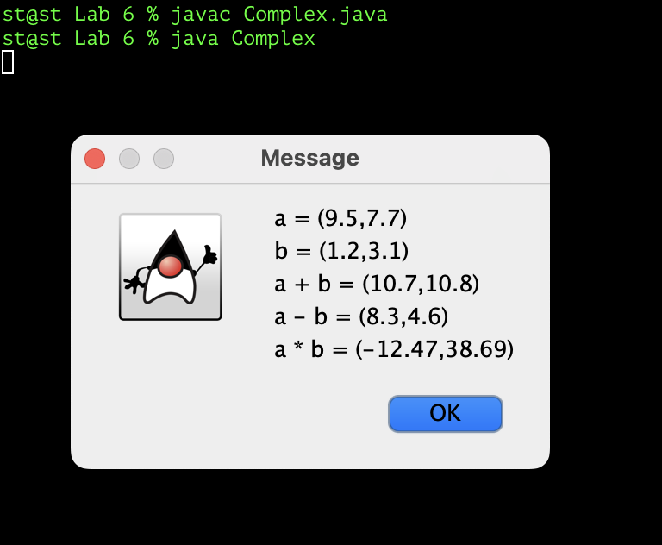

**Conclusion:**

During the coding process, I have some problems with writing the methods for complex numbers since they need to be declared with 2 attributes of the real and imaginary part. I also understand more about how to create and call a method of a class and understand about how a constructor initializes a class attribute. As a result, my program can create a Complex class to perform arithmetic with complex numbers, including adding 2 complex numbers, subtracting 2 complex numbers, and multiplying 2 complex numbers, then printing the result in a Message Dialog Box. So, the objective of lab 6 has been done.